**RELIGIOUS EDUCATION IN THE EARLY YEARS**

**(Yr 1-2)**

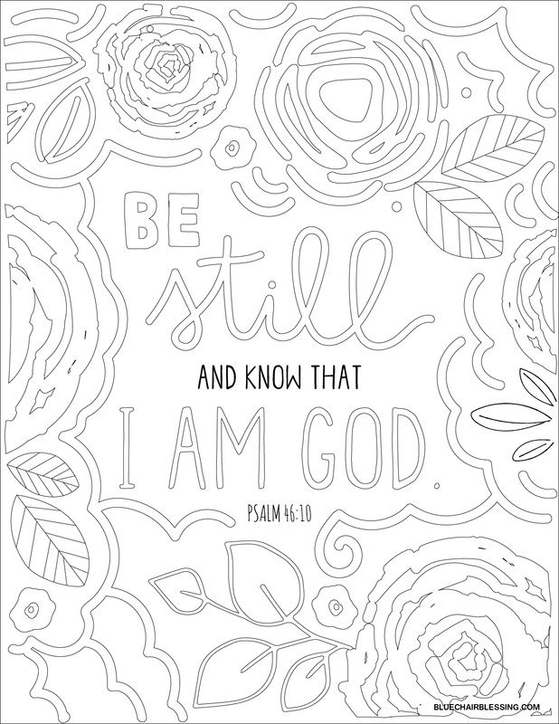

**~ PERTH**

**Joanne Harris**

**Religious Education & Faith Formation Consultant**

**joanne.harris@cewa.edu.au**

**PRAYER**

What did you see?

How could you use these ideas in your own staff prayer?

How could you use these ideas in your class prayer?

What are some other ideas for prayer?

**GOD IS REACHING OUT PERSONALLY TO ME THROUGH…**

***…HUMAN YEARNING***

*~ When have I sought answers to human experiences and heart aspirations (eg. yearning for real happiness, for truth, for peace, for justice)?*

***…THE CREATED UNIVERSE***

*~ What are some moments when I have become aware of the presence of a Greater Being through creation (eg. a sunset, a forest, a new born baby, the death of a friend)?*

***…THE PROMISE OF SALVATION***

*- human ‘hope’ of being saved or transformed.*

*As I reflect upon my life I sense a need to be the person I am called to be (eg. How do I desire to be a better person? What do I yearn to change for the better? What bad habit do I wish to overcome? What negative attitudes do I know I need to change, etc.?)*



**...THE COMING OFJESUS CHRIST** *Jesus is the climax of revelation and shows us how to relate with our Creator.* ~ What have been my *experiences of* God when pondering or celebrating questions about God, about Jesus, about Scripture?

***…THE PROMISE OF SALVATION***

The human ‘hope’ of being saved or transformed.

*~ As I reflect upon my life I sense a need to be the person I am called to be. How do I desire to be a better person? What do I yearn to change for the better? What bad habit do I wish to overcome? What negative attitudes do I know I need to change?*

***…MY EXPERIENCES OF CHURCH AND THE STRENGTH AND GIFTS OF THE HOLY SPIRIT***

*~ When has a liturgy particularly moved me – a wedding, funeral, Eucharist, Reconciliation service; a theology course, an apostolic work, care for the needy, strength received through prayer, etc…?*

**WEBSITES AND RESOURCES FROM THE DAY**

* RE in the Early Years website (the weebly) – [www.reintheey.weebly.com](http://www.reintheey.weebly.com).
* Welcome to Country app - <https://itunes.apple.com/au/app/welcome-to-country-australian/id1005047597?mt=8>.
* “Images of God for Young Children” by [Marie-Helene Delval](https://www.eerdmans.com/Authors/Default.aspx?AuthorId=17871)
* “Shhh…God is in the Silence: A Story for all Ages” by Fiona Basile
* Praying in Color – <https://prayingincolor.com/>
* Love my Books - <http://www.lovemybooks.co.uk/>
* “Into the Desert” by Dan White and Kate O'Brien - <https://bookshop.ceosyd.catholic.edu.au/store/comersus_viewItem.asp?idProduct=1480>
* Catholic Icing printable peg doll sets (Passion, Easter and Nativity) – <https://www.catholicicing.com/printable-peg-dolls-just-paint-the-head-and-decoupage-the-rest/>
* Wooden peg dolls - <https://www.amazon.com.au/gp/product/B017DOVWDY/ref=ppx_yo_dt_b_asin_title_o01_s00?ie=UTF8&psc=1>
* Bible Paper Toys (free download) - <http://www.mylittlehouse.org/bible-paper-toys.html>

**NOTES**

**MY GOALS FROM THE DAY**

**RE CURRICULUM:**

**OTHER:**

**MY HOPE/S FOR THE DAY…**

**Do not write any notes on this page!!!**

**FEEDB AC K FROM RE IN THE EARLY YEARS 2019 (Yr 1-2 Perth)**

The learning intentions of the day are for participants to:

* Gain a greater understanding of the new RE curriculum Yr 1-2, planning with it and resources from it.
* Broaden their repertoire of strategies and resources to enhance the teaching of RE in their early years class.
* Explore the different Biblical translations and their features.
* Network and share with other Yr 1-2 teachers.
* Create goals for themselves in relation to their learning.

Did you feel the activities throughout the day met these intentions? Please explain your answer.

What could have been done to improve the day? Were your hopes met?

What would you like to see covered in future RE in the Early Years professional learning?