RE IN THE EARLY YEARS
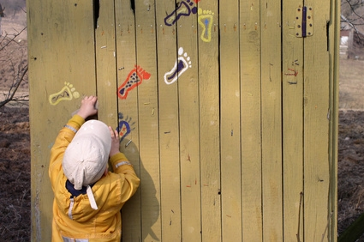
~ KINDY 2013
Jo Harris
Consultant
Religious Education and Faith Formation
Catholic Education Office
harris.joanne@cathednet.wa.edu.au
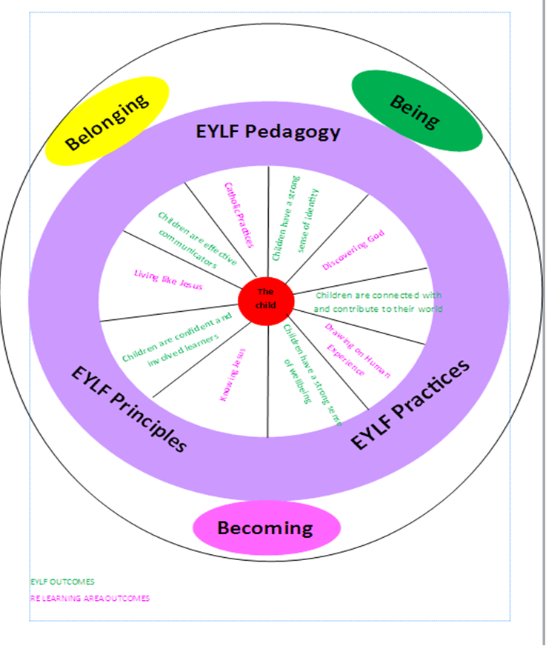
THE LINKS BETWEEN THE EYLF AND THE RE OUTCOMES
NOTES:

LET THE LITTLE CHILDREN COME TO ME
AND
THE EARLY YEARS LEARNING FRAMEWORK

This resource complements the vision for learning as outlined in The Early Years Learning Framework (EYLF) for Australia. The Framework is implemented in Catholic schools within the context of a distinctive Catholic curriculum which aims to develop children as followers of Jesus in today’s world. The fundamental experiences of belonging, being and becoming are integrated throughout the Let the Little Children Come to Me document.

“Experiencing belonging – knowing where and with whom you belong – is integral to human existence…Belonging acknowledges children’s interdependence with others and the basis of relationships in defining identities.” (The Early Years Learning Framework for Australia, p.7) When raising religious awareness in the early years, children learn that they belong to God’s family; they develop their understanding of how Jesus teaches people to live and they learn how to relate to others in God’s family.

“Being recognises the significance of the here and now in children’s lives. It is about the present and knowing themselves, building and maintaining relationships with others, engaging with life’s joys and complexities, and meeting challenges in everyday life.” (The Early Years Learning Framework for Australia, p.7) When raising religious awareness in the early years, children learn of God’s great love for them and how they are created for a special relationship with God. They are wonder-filled at God’s creation and explore with awe and curiosity the world and their place in it.

“Becoming reflects the process of rapid and significant change that occurs in the early years as young children learn and grow. It emphasises learning to participate fully and actively in society.” (The Early Years Learning Framework for Australia, p.7) This Resource guides educators to provide experiences of sacred stories, liturgical rituals, prayer and silence so that young children increasingly participate in the life of the Church. Through their learning they will also come to know Jesus and the ways he has called us to live our lives, while being given opportunities to demonstrate this Christian living in their daily lives.
The principles of the EYLF underpin everything done in a good early years classroom and so should be evident as student’s religious awareness is developed. Below is a table highlighting just some of the ways that the EYLF principles could be demonstrated within an early years program in a Catholic school.

EYLF Principles | Examples from the Catholic Kindergarten classroom
Secure, respectful and reciprocal relationships | - Modelling Jesus’ love for everyone.  - Making the connections between how students relate to one another and Jesus and his teachings.  - Featuring individual intentions in class prayer time.  - Learning about how God gave people feelings.
Partnerships with families | - Discussing how the religious awareness of students is raised in the classroom at orientation meetings, in class newsletters and at parent meetings.  - Including religious awareness learning in Learning Journeys or Open Nights.  - Being aware of different faiths in the classroom and referring to them occasionally.  - Involving parents in liturgical events - class Liturgy of the Word, school celebrations, Mother’s day liturgy.
High expectations and equity | - Considering the planning for raising religious awareness when writing IEPs and CAPS.  - Including scope for differentiation of learning in planning for raising religious awareness.
Respect for diversity | - Discussing gifts and differences in the light of God’s creation.  - Acknowledging students of different faiths and their celebrations.  - Celebrating liturgies or using special prayers on special days such as Harmony Day/NAIDOC week.  - Discuss different cultural traditions for special religious celebrations (eg. Christmas/Easter).
Ongoing learning and reflective practice | - Attendance at relevant Religious Education workshops and PDs.  - Participation in networking opportunities around the raising of religious awareness in Kindergarten (eg. RE in the Early Years Ning)  - Including Religious Education in ongoing cycle of review.

The practices identified in the EYLF are best educational practice in an early years classroom and should be considered in the planning of any RE program. Teachers in Catholic Kindergartens are mandated to draw on a rich repertoire of pedagogical practices to promote children’s religious learning by:
- adopting holistic approaches
- being responsive to children
- planning and implementing learning through play
- intentional teaching
- creating physical and social learning environments that have a positive impact on children’s learning
- valuing the cultural and social contexts of children and their families
- providing for continuity in experiences and enabling children to have successful transition
- assessing and monitoring children’s learning to inform provision and to support children in achieving learning outcomes.

The EYLF and CEOWA Religious Education outcomes can be simultaneously accommodated through the program to raise religious awareness and these links are made throughout this resource, in addition to being outlined in the diagram above.

LEARNING OUTCOMES FOR CATHOLIC EARLY YEARS STUDENTS
EARLY YEARS LEARNING OUTCOMES | RE LEARNING OUTCOMES | HOW IS THE OUTCOME EXPRESSED IN THE EARLY YEARS?
CHILDREN HAVE A STRONG SENSE OF IDENTITY  - feel safe, secure and supported  - develop their emerging autonomy, interdependence, resilience and sense of agency  - develop knowledgeable and confident self-identities  CHILDREN ARE CONNECTED WITH AND CONTRIBUTE TO THEIR WORLD  - develop a sense of belonging to groups and communities and an understanding of the reciprocal rights and responsibilities for active community participation  - respond to diversity with respect  - become aware of fairness  - become socially responsible and show respect for the environment  CHILDREN HAVE A STRONG SENSE OF WELLBEING  - become strong in their social and emotional wellbeing  - take increasing responsibility for their own health and physical wellbeing  CHILDREN ARE CONFIDENT AND INVOLVED LEARNERS  - develop dispositions for learning such as curiosity, cooperation, confidence, creativity, commitment, enthusiasm, persistence, imagination and reflexivity  - develop a range of skills and processes such as problem solving, enquiry, experimentation, hypothesising, researching and investigating  - transfer and adapt what they have learned from one context to another  - resource their own learning through connecting with people, place, technologies and natural and processed materials  CHILDREN ARE EFFECTIVE COMMUNICATORS  - interact verbally and nonverbally with others for a range of purposes  - engage with a range of texts and gain meaning from these texts  - express ideas and make meaning using a range of media  - begin to understand how symbols and pattern systems work  - use information and communication technologies to access information, investigate ideas and represent their thinking | DISCOVERING GOD  Students understand that people come to discover God through experiences in creation. | Discovery  Investigation  Opportunities to;  - Wonder  - Explore  New knowledge and building on existing knowledge
 | DRAWING ON HUMAN EXPERIENCE  Students understand the content of the Christian message and its significance by relating it to examples drawn from human experience. | Exploring to expression of human experience  Personal experiences  Family experiences  Church experiences
 | KNOWING JESUS  Students know the person of Jesus, the model for living out the Christian mission in the world. | Engage with stories of Jesus.  Play  Oral language  Godly play
 | LIVING LIKE JESUS  Students understand that Catholics are empowered to live like Jesus the Saviour as they draw on the power of God’s Spirit. | Action  Modelling  Dramatic Play  How we relate in the Early Learning community.  Attributes of the Kingdom.  Discipleship
 | CATHOLIC PRACTICES  Students demonstrate the skills necessary in order to read and apply Scripture to life and to participate in Catholic ritual and prayer | Scripture  Prayer  Liturgy  The Two Great Commandments
RELIGIOUS EDUCATION OUTCOMES
– WHAT AND HOW TO TEACH IN KINDY
THE WHAT –
Religious Education in the early years aims to provide students with the opportunity to discover God in people and creation by:
- experiencing the created environment, using all of their senses
- expressing basic ideas about the created environment in which they live
- sorting and classifying living and non-living things
- identifying signs of God’s creation
- wondering at what God who created their world is like
- developing an awareness that by caring for living and non-living things they are living as God wants
- discovering things about themselves
- identifying significant others
- recognising people and places of importance
- wondering at all the ways God loves them
- developing an awareness that by caring for people they are living as God wants.

Religious Education in the early years aims to provide students with the opportunity to draw on human experiences of God by:
- identifying the many gifts that God has given them
- reflecting on experiences of family, love, care, forgiveness and community
- exploring a range of human interactions
- demonstrating socialisation into the early years community
- reflecting on experiences of play and work, likes and dislikes, belonging and celebrations
- wondering at God in the midst of human experiences.

Religious Education in the early years aims to provide students with the opportunity to know Jesus by:
- wondering at the person of Jesus in the Gospels
- wondering at Jesus’ love for them
- hearing and being immersed in stories about the life of Jesus
  - identifying significant people in the life of Jesus
  - identifying the way that Jesus loved and cared for people
  - engaging in play experiences based on the stories of Jesus
  - responding to stories about Jesus
  - exploring and making meaning of Scripture.

Religious Education in the early years aims to provide students with the opportunity to live like Jesus by:
- naming ways that people can show love and be considerate like Jesus
- identifying ways of including people based on how Jesus included them
- exploring ways of forgiving like Jesus forgave
- identifying ways of choosing to do good following the example of Jesus
- wondering at the love that Jesus had for all people
- using their special gifts to help others
- wondering at the ways they can use their gifts to help people
- knowing special people who like Jesus used their gifts to help others in particular ways
  - Mary, the mother of Jesus
  - Joseph
  - Some saints (patron saint of the school or founding order)

Religious Education in the early years aims to provide students with the opportunity to develop a basic understanding of Catholic life, prayer and Scripture by:
- knowing that prayer is the way that people talk to and listen to God
- recognising religious symbols including the cross, liturgical colours and holy water.
- knowing simple ways of praying - making the Sign of the Cross, joining hands in prayer, singing.
- engaging in informal prayer experiences i.e. prayers of praise, thanks, sorrow, petition, spontaneous prayers or through song or movement
- participating in rituals (e.g. Children’s Liturgy of the Word, having a set process of coming into prayer)
- appreciating the importance of Christmas and Easter as special celebrations for the followers of Jesus
- developing an awareness that God’s family is called the Church
- coming to know of the relationship between Jesus and the Father
- developing an awareness that Jesus came to tell people about God’s love
- meeting the parish priest and knowing of his role in the Church
- visiting the parish church and learning of its role as the place that gathers God’s family
- knowing how God’s family celebrates and experiencing liturgies and other appropriate school catechesis activities
- recognising the Bible as the special book that tells people about God’s love
- observing, manipulating and retelling Scripture stories using pictures and other objects
- participating in ritual to listen to and respond to Scripture.

THE HOW –
To develop religious awareness in the early years, the learning environment needs to provide opportunities for children to:
- explore God’s creation
- engage in human experiences that relate to religious concepts
- engage in role-play that helps develop their religious awareness
- recall and retell scripture stories
- see modelled how to relate with others in the way Jesus taught
- be encouraged to wonder
- be introduced to simple ritual.

Young children learn best with secure, respectful relationships in a safe and predictable environment.
- Priority is given to nurturing relationships, providing children with an environment which enables them to experience the joy and wonder of the world.
- Children are assisted to learn about their responsibilities towards others.
- The connectedness of the mind, body and spirit is recognised.
- Planned, intentional teaching in addition to spontaneous ‘teachable moments’ are used to scaffold children’s learning.
- Provision for different learning capacities and styles.

Young children have a natural capacity for curiosity, imagination and wonder and learn through symbols and rituals.
- Open-ended questions are used and all ideas and attempts are accepted.
- Symbols and rituals nurture the child’s curiosity, imagination and sense of wonder.
- The curriculum engages children with the signs, symbols and rituals of the church as a means of learning.

Young children learn through story.
- Scripture stories and stories of the tradition are key elements of the curriculum.
- Opportunities for exploration help engage students with the stories.
- Appropriate children’s literature is included in the curriculum.

Young children learn through play and sensory experiences.
- Children are active participants in their learning.
- A balance between child led, child initiated and educator supported learning exists.
- Students are engaged in sustained shared conversations to extend thinking.
- Materials are suited to students’ needs and available for their use.
- Concrete materials, visual materials and the creative arts support the learning needs of early years students.

Adapted from Archdiocese of Sydney Religious Education Curriculum Primary Kindergarten, Catholic Education Office Sydney, p. 18.

Planning a Prayer Ritual

WE GATHER
- Chose the objects and symbols that you will use in the sacred space.
- Gather children around the sacred space and bring them to a quietness – use reflective music, prayer bells, chimes, a rainstick etc.
- Create the sacred space with the students – discuss why you may have chosen each of the symbols/objects. (eg. You may say something like “I wonder why we might have the symbol of the cross in our sacred space today?)
- Light the candle and say something like “Let us watch as our class candle is lit… let’s watch the flame and see it grow and move. There was once a man who said such amazing things and did such wonderful things that people asked him who he was and once Jesus said to them – I am the light of the world.”
- Sing a song.
- Make the Sign of the Cross.
- Say a simple opening prayer. (eg. We come today to spend some time with Jesus and hear about how He wants us to live. We ask Jesus to help us listen with our ears and our hearts. Amen.)

WE LISTEN
- Listen to a story about Jesus. Ritualise this by:
- bringing the candle close to you and the Bible , or
- if you are telling the story, by opening the Bible and placing it in your lap as you start the story, or
- leading students in a ritual similar to the one done at Mass. “Let us trace a cross on our forehead with our thumb. This will remind us that this is a special story about Jesus and we will need to think about it as we listen. Let us trace a cross on our lips with our thumb. This will help us to remember to use good and kind words to be like Jesus. Let us trace a cross with our thumb on our hearts. This will help us to remember that Jesus loves us and wants us to love others.”
- Read or tell the scripture story.

WE RESPOND
- Pass the Bible or the candle around the circle. As the book comes to a child he/she is invited to say “Jesus loves me” or some other response to the story.

WE GO FORTH
- Invite children to make the Sign of Peace with each other.
- Make the Sign of the Cross.
- Sing a song.

My Kindy Prayer Ritual
Using the Gather, Listen, Respond and Go Forth framework plan a prayer ritual for your class.
WE GATHER

WE LISTEN

WE RESPOND

WE GO FORTH

PRAYER AND LITURGY WITH KINDY STUDENTS

CREATING A SACRED SPACE FOR PRAYER & REFLECTION
From Let the Little Children Come to Me

A prayer focus should form a prominent part of the early years classroom. The area should be accessible and uncluttered, added to or changed regularly to reflect what is happening in relation to the learning that is taking place in the classroom and the liturgical season.
The children should have a sense of ownership and be encouraged to share the responsibility for creating and keeping the sacred space.
This sacred area should be a place that gives children both a sense of community and provides opportunities for quiet reflection.
The following list contains the essential symbols for a prayer focus but there are many possibilities for what can be added depending on the experiences and activities of the class.

Cross At this age level it is best to talk to children about how the cross reminds us of Jesus who loves us and who will always help us to do things that are hard. Jesus shows us how to love and care for others.
Bible The Bible is a special book and we treat it with reverence and respect. We can listen to God by reading the Bible. We learn about Jesus’ life through stories in the Bible. It is far more inviting to have the Bible open to a story you have been telling, than to have it closed on the table. This encourages students to take the book and read it.
Candle It is effective to ritualise the reading or telling of the Word of God by lighting a candle. In this way, students are reminded that Jesus is with us as we listen to the Word of God in the Bible and it differentiates this story from all others used in the classroom.
Bowl of Water Have a small bowl of holy water on the prayer focus. Demonstrate how to dip fingers in the water and make the Sign of the Cross and explain how people bless themselves with holy water and make the Sign of the Cross to show that God is with them.
Coloured Fabrics It is appropriate to use coloured cloths that reflect the liturgical season as part of the focus. For example, the cloth might be purple in Advent and Lent or white when celebrating Easter or a saint’s feast day. See appendices for information regarding the Liturgical Year and colours used.

The changing of the prayer focus is a ritual that can assist young children to develop and understanding of the Church seasons. The following links outline these simple rituals and what you could use and say:
Introduction of prayer focus for beginning of year -http://www.ceosyd.catholic.edu.au/Parents/Religion/RE/recurr/tres-curr-K.1.doc (see p. 40/41)

Introduction of prayer around prayer focus -
http://www.ceosyd.catholic.edu.au/Parents/Religion/RE/recurr/tres-curr-K.1.doc (see p. 42/43)

Introduction of Bible stories from the Bible on the prayer focus -
http://www.ceosyd.catholic.edu.au/Parents/Religion/RE/recurr/tres-curr-K.1.doc (see p. 44)

Introduction to use of holy water on prayer focus -
http://www.ceosyd.catholic.edu.au/Parents/Religion/RE/recurr/tres-curr-K.1.doc (see p. 45)

Introduction to a Lenten prayer focus - (written for older year levels, but gives you an idea of some symbols you could use)
http://www.ceosyd.catholic.edu.au/Parents/Religion/RE/recurr/tres-curr-3.2.doc (see p. 15)

Introduction to an Advent prayer focus -
http://www.ceosyd.catholic.edu.au/Parents/Religion/RE/recurr/tres-curr-3.8.doc (see p. 139)

Our Prayer Place

PART I

YOU WILL NEED:
* a small table ready
* a box or basket containing a green cloth, Bible/bookstand, candle, cross and matches next to your chair

Invite children to sit reverently in a circle in the part of the classroom where you intend to set up a prayer place. Begin by saying…
In our classroom we are going to make a special prayer place to be with God. It is a place we can be quiet with God. We can listen to God and talk to God. In this prayer place we will have some special objects to help us to be with God. Let’s look at some of these special objects.
Place the table in the prayer place.
First we will put this table in our prayer place to keep our special things on.
Cover the table with the green cloth.
At this time of the year we put a green cloth on the table. Green is a colour that reminds us that God is with us all the time.
I wonder what else we might put in our prayer place. Let’s see…Here we have a Bible.
Take out and hold the Bible up for all children to see. Be conscious of handling the Bible in a reverent manner.
The Bible is a special book which has lots of stories. We can hear some of the special stories of God from the Bible, here in our prayer place. I wonder where else you hear special stories about God …
When we carry our Bible or when we read from our Bible we hold it carefully and gently just like this.
Demonstrate how to carry, lift and hold the Bible in a reverent manner. Invite one or two children to demonstrate how to carry, lift and hold the Bible. Give praise.
Let’s put our class Bible in a special place in our prayer place.
Place the Bible on a stand on the table.
I wonder what else we might put in our prayer place…Let’s see.
Take out cross and show to children.
Here we have a cross. I wonder where else you might see a cross…
This cross reminds us of our special friend Jesus. In our prayer place we can hear some of the special stories of Jesus from the Bible and we can wonder about Jesus together. Let’s put our cross in a special place on our prayer place.
Place the cross on the table.
I wonder what else we might put in our prayer place…Let’s see.
Take out candle and show to children.
Look, a candle. I wonder why we have a candle for our prayer place…
In our Church we light candles to remind us that Jesus is always with us. We can light the candle when we are talking to God or when we are listening to special stories of God from the Bible.

Let’s put our candle in a special place.
Place the candle on the table.
This is our prayer place.
Point to all four objects as you name them again.
It has a green cloth, a Bible, a candle and a cross. It is a very special place.
When we are in our prayer place, it is a special time in class when we can talk to God. When we say a prayer to God we hold our hands like this, watch:
Demonstrate how to hold hands together for prayer.
Let’s see if you can do it… Give praise.
We can begin with a special prayer called The Sign of the Cross. It goes like this, watch:
Say and make the Sign of the Cross.
In the name of the Father, and of the Son and of the Holy Spirit. Amen.
Let’s see if you can do it…
Continue to demonstrate and encourage children to copy the words and action for the Sign of the Cross. Give praise.

Our Prayer Place

PART II

You will need:
- 6-8 tea light candles
- matches
Invite children to come to sit in the prayer place.
Let’s see if we remember some of the special objects in our prayer place.
Briefly point to and name the special symbols on the prayer place, green cloth, Bible, candle, cross.
When we are in our prayer place we can talk to God. Do we remember how to hold our hands together for praying… Let’s begin with our special prayer called The Sign of the Cross. Let’s see if we remember how it goes. It goes like this, watch:
Say and make the Sign of the Cross.
In the name of the Father, and of the Son and of the Holy Spirit. Amen.
Let’s see if you can do it…
Say and make the Sign of the Cross together.
When we are in this prayer place we try to walk more gently and talk more quietly so we do not disturb others. We try to listen carefully to others. In this special prayer place we can be with God, we can talk to God and listen to God. We can hear some of the special stories of God from the Bible and we can wonder about God together. When we come to our special prayer place we need to get ourselves ready to be with God. Let’s see how we will get ourselves ready to be with God.
When we come to the floor or the circle we need to walk gently and slowly and find a space to sit.
Invite a child to walk to their table/desk and back again. Give a few children a turn. Practice with whole class walking to their seats and back again.
Another thing to remember when we are in our special prayer place is to speak in a quiet voice and to listen to others when they are speaking. We need to give everyone a chance to speak and wonder about God. If we are too noisy we might disturb someone who is speaking to God or listening to God. Let’s see if we can speak clearly and listen quietly. Ready? Listen: My name is….
Give all children an opportunity to say their names in a clear voice. My name is…
When we are getting ready to listen to one of the special stories of God from the Bible we need to sit in a special way. We sometimes sit by crossing our legs and putting our hands in our laps. Sometimes, when it is a special story from the Gospel our Church always stands, so we do this too. I wonder if you can do that.
Invite a child to demonstrate how we need to sit and how to stand. Encourage all children to have a go. Give praise.
When we are listening to one of the special stories of God from the Bible we need to become very quiet. We can get quiet by making ourselves very still. Let’s try to make our bodies very quiet and still. This is how. Close your eyes and listen to the quietness…Make your whole body still…See if you can make your legs and feet very still…See if you can make your arms and hands very still…See if you can make your head and shoulders very still…Feel all of your body getting very still. Now feel your own breathing… Feel yourself breathing in and breathing out…breathing in and breathing out… in…and out… Feel your breathing become slower and quiet… Now we are ready to listen to one of God’s special stories. Open your eyes and be ready. This is a story about the Light.

Place the candle from the prayer place in front of you where all children can see it.
Once there was someone who seemed so wonderful that lots of people wanted to be near him. They followed him everywhere. They wanted to know more about him and all the magnificent things he did. One time he said to them ‘I am the Light of the world’.
Light the candle on the word ‘Light’.
Let’s enjoy the light together.
Sit quietly enjoying the light.
Many people followed the Light and loved the Light. People who love the Light became one with the Light. Watch.
Hold up a tea light candle and say…
This is one person’s light.
Light the tea light candle from the class candle and place it next to the class candle. Take up another tea light and say…
This is another person’s light.
Light the tea light candle from the class candle and place next to the first tea light. Repeat action and words for a further four candles, then say…
Look at the light. It is growing and getting bigger. All the light came from the Light here.
Point to the class candle.
The Light is in many places at the same time.
Point to the small candles and light one or two more.
The Light is not smaller. It is still the same…I wonder how the Light can stay the same even though so much light is given away.
Point to the class candle.
Many people come to the Light and receive their light. They become one with the Light because they love the Light. Your light and my light can become one with the Light too. Watch. This is my light.
Light another tea light and place with the others.
Let’s enjoy the Light.
Sit quietly enjoying the light.
Let’s make something that shows how this story about the Light feels to you. I will give you some crayons and some paper and you can make a picture about the Light. You can work on your table or on the floor here.

Our Prayer Place

PART III

You will need:
- Bible
- class candle
- matches
- bookmark

Invite children to come to sit in the prayer place.
When we are in our prayer place we can talk to God and we can listen to God too. We begin with a special prayer called The Sign of the Cross. Let’s join our hands together and see if we remember how it goes. It goes like this, watch:
Say and make the Sign of the Cross.
In the name of the Father, and of the Son and of the Holy Spirit. Amen.
Let’s see if you can do it… Give praise
Take the Bible and hold it up for all children to see.
The Bible is a special book. We can listen to God by reading the Bible.
And we light our class candle to remind us that Jesus is still with us as we listen to the Word of God in the Bible.
Light the class candle.
The story we heard before about the Light is in the Bible. Let’s look.
Open the Bible to John 8:12 and turn it so the children can see the words. Then read the words slowly and reverently. Pause for a moment and then lead children through ‘I Wonder’ questions…
I wonder who is like the Light.
I wonder how it feels to be one with the Light.
I am going to put a bookmark in the Bible to mark the place where the story about the Light is found. You might look at these words yourself later, or someone might read them to you.
Put the bookmark in the Bible and place the Bible reverently back on its stand in the prayer place.
Now let us talk to God and say thank you to God. You can say one thing you are thankful for or you might say something about the story of the Light. You can say your prayer out aloud or you can say it quietly. God can hear us even if we don’t speak out aloud. God listens to us all the time. If we want to pray aloud we need to remember to wait for our turn. If one person is speaking we have to listen and wait for our turn. Let’s join our hands together ready to pray…
Give enough time for prayer. Encourage silent spaces. When the praying is over, say…
Let’s finish by making the Sign of the Cross together.
Say and make the Sign of the Cross.
In the name of the Father, and of the Son and of the Holy Spirit. Amen.
Invite children to walk quietly back to tables/desks.

Our Prayer Place

PART IV

YOU WILL NEED:
- small bowl of water

Invite children to come to sit in the prayer place.
When we are in our prayer place we can talk to God and we can listen to God too. Our prayer place is a special space we can be with God. I wonder if you know other special places to be with God…
Encourage a variety of responses.
The Church building is a special place where lots of people gather to be with God, to talk to God and listen to God. It is a big space so there is room for everyone. When people enter the Church they move slowly and quietly and talk gently as a sign of reverence. I wonder what it means to be reverent…
Invite a child to walk to the door and back again in a slow, gentle manner. Give a few children a turn. Practise with whole class walking around the room and back to the prayer place again.
When people enter the Church they dip their fingers in holy water and make the Sign of the Cross just like this…
Demonstrate how to dip fingers in the water and make the Sign of the Cross.
People bless themselves with holy water and make the Sign of the Cross to show that God is with them.
Invite one or two students to have a go at blessing themselves. Practise with everyone.
Let’s put the bowl of water on our prayer place to remind us about blessing ourselves with the Sign of the Cross to show that God is with us.
Place bowl of water on prayer place.
Another thing people do to get ready to be with God in the Church is to genuflect just like this…
Demonstrate how to genuflect. Repeat a few times as you say…
People genuflect when they come into the Church to show they know Jesus is with them in a special way in the Church.
Practise genuflecting with students. Give praise.
Visit the Church building and identify some key objects there – altar, statues, font, lectern, tabernacle, cross. Practise blessing with holy water and genuflecting. Allow a short time for students to sit in silence and enjoy the quiet and stillness.

The script for Our Prayer Place is based on ideas from:
To Know Worship and Love – Kindergarten, Chapter 1, (2005), James Goold House Publications, Melbourne, Victoria
Stewart Sonja M and Berryman Jerome W (1989), Young Children and Worship, Westminster John Knox Press, Louisville
From CEO Melbourne
DEVELOPING SIMPLE PRAYER RITUALS
From Let the Little Children Come to Me

Simple prayer rituals invite children to communicate with, and develop a relationship with God. In the early years, educators encourage children’s awareness of God through modelling talking to God, and talking about God, in a way that gives witness to God’s love and mystery and God’s presence in the midst of everyday life.
For example, during greeting time, the teacher might say;
“Now that we have said good morning to each other and to the other people in our centre, I would like to say good morning to someone who is always with us and who loves us very much - God.”
At the beginning of the year, prayers should be kept as simple as possible such as ‘Good morning God, it’s me. Thank you for today.’ As the year progresses these can then be developed into spontaneous prayers of praise, thanks and petition e.g. “Hello God, thankyou you for my family.”
The church has a rich tradition and variety of prayers which can be offered to children of this age including verbal prayers, simple meditation based on wonder and simple prayers offered through song and dance.
LEADING YOUNG CHILDREN TO MAKE THE SIGN OF THE CROSS AND TO JOIN THEIR HANDS IN PRAYER
The teacher models making the Sign of the Cross, using the left hand, facing the class to allow children to mirror the actions, whilst using the formal language of the Sign of the Cross.
One example for leading children to the formal language of the Sign of the Cross could be by saying;
“God is in my head, in my heart and looking over my shoulder,” whilst making the Sign of the Cross.
When students have mastered the actions for making the Sign of the Cross, they can be lead to formalise the ritual with the words “In the name of the Father, and of the Son, and of the Holy Spirit. Amen”
Another example for encouraging children to join their hands reverently is by saying;
“We hold God carefully in the palm of our hands”, while modelling the action with reverence.

My Finger Prayer

Here is a prayer that uses the child’s hand as a reminder of what to pray for.
My thumb is closest to my heart – pray for my family.
My index finger points out things we don’t always see; it instructs me – pray for teachers.
My middle finger stands taller than the rest – remember to pray for the president and leaders around the world.
My ring finger is weak and cannot stand alone well – pray for the weak and the sick.
My pinkie finger is the smallest – remember to pray for myself.
From http://suite101.com/article/prayers-for-young-children-a19131#ixzz2JXEkoyG4.

Pray at Home Bag for under 5s
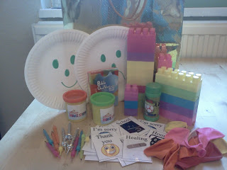

Into a large gold gift bag we have put:
Smiley and sad faces on paper plates, duplo bricks, playdough pots, bubbles, balloons, prayer grab bag, birthday cake candles, and a children’s Bible. Most of these things were found at the Red Dot shop, so putting it together was not expensive!

Inside the bag will also be instructions on how to use each item to pray with children.

Prayer Grab Bag
Shake the tin, close your eyes and pull a card out.
Homes- say thank you for your house
School- ask God to bless a teacher or thank Him for your favourite thing at school
Friends- thank God for a friend
Thank You- Say thank you for something of your choice!
Family- ask God to bless someone in your family
Food- thank God for your Favourite food
Healing- ask God to make someone better
I’m sorry- say sorry to God for something you wish you hadn’t done

Lego Thank You Tower
Build a lego tower. Each person who adds a block has to say thank you for something God has given them.

Bubble prayers
Blow some bubbles. Say thank you to God for something or ask him to help someone. Pop a bubble for each thing you pray. Or
If you feel worried about something, tell God about it and watch the bubbles float away or pop them to show that you have given that worry to God.

Playdough prayers
Shape the playdough into something you’d like to thank God for- especially something in creation.

Happy and sad faces.
Use the sad face to tell God about the things that make you sad. Ask him to help you.
Use the happy face to tell God about the things that make you happy. Say Thank you to Him

Balloon prayers.
Blow up 3 balloons and write or draw on them things you want to say Thank You to God for. Play some music and bat the balloons around. When the music stops say ‘thank you God!’. Start again!

Candle Prayers.
Stick the birthday candles into something firm such as an orange. Light the candles. Give a blow. Count how many candles are still burning. Thank God for that many things! Or
Light a candle for each person in your family. Say their names and ask God to bless them. Blow out the candles!

Adapted from http://flamecreativekids.blogspot.com.au/2012/02/pray-at-home-bag-for-under-5s.html

THE INFANCY NARRATIVES
~ BIBLICAL CONTEXT
ASPECT OF THE STORY | NOTES | HOW I MIGHT INCORPORATE THIS INTO MY KINDY
BETROTHALS
ADULTERY
JOSEPH
TIMING

BETHLEHEM
HOSPITALITY
LOCATION

THE MAGI HEROD

MOSES
HEROD
NAZARETH

QR Codes: Attaching audio files
Adapted from a post on April 15, 2013 by technologyforearlychildhood@gmail.com
One of the first obstacles I encountered as I was thinking about ways to use QR codes with preschoolers was using information that didn’t require reading. I knew that if I really wanted to have fun with QR codes with my students, I was going to have to find an easy way to attach an audio file to the QR code so that my children wouldn’t have to read the information they received when they scanned a code. After much research and clicking on the internet, I finally found something that worked. Here’s my final product. Keep reading below to find out how I put it together.
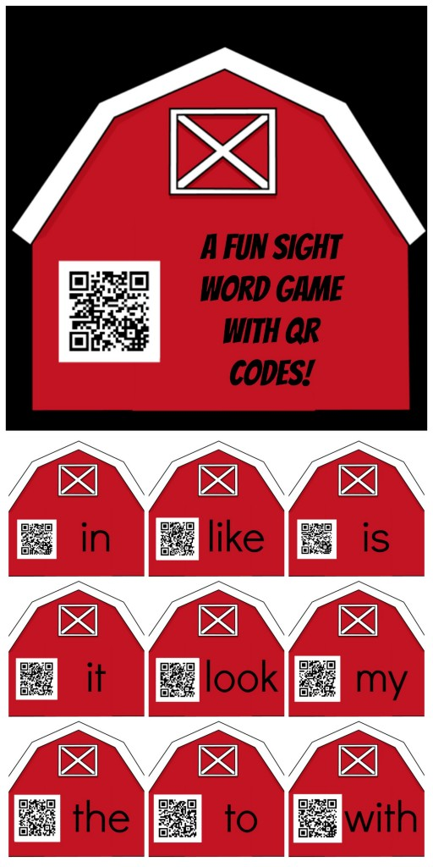
First I needed to find a website that would let me record an audio file online and store it at a particular URL. There are many sites that do this, but I needed a little something extra. I needed the site that I found to automatically play the audio file once the user scanned the QR code. I learned from our Counting to 20 with QR codes lesson that our preschoolers simply can’t handle too many steps or they get bogged down. Having to scan the code, and then press play to hear the task, and then complete the task likely would have pushed them over the edge. I checked a few sites and finally found this one: http://www.recordmp3.org/ Record MP3.org is super easy to use. You can create and upload a MP3 file in just a few steps and then the program spits out a url.
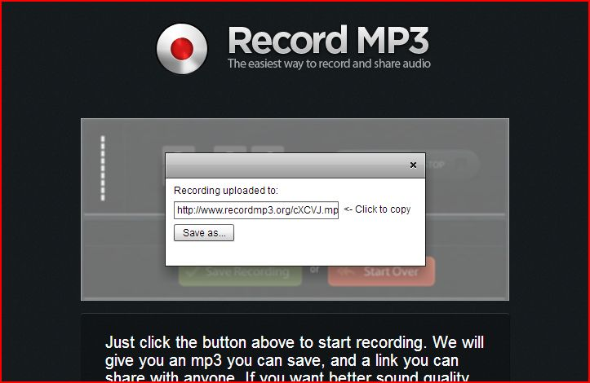
I took the URL from Record MP3 and pasted it into my favorite QR code producer and generated a QR code. (Click here to read about making QR codes ) Now the QR Code that I just created links to the audio file so that when the QR code is scanned, it plays the words that I recorded. Getting this set up to work right was the key to creating my sight word activity.
To make the activity, I created 36 audio files, and then a QR code for each audio file. Eighteen of the audio files give a direction to find a particular sight word, “Find the word the.” The other 18 files identify the sight word that the child found. “You found the word the.” I put the QR codes into a document and spiced them up with some graphics. (We’re kicking off our big “farm” unit, so I went with a barn theme. ) Then it was time to play a little sight word matching game!
Each child had their own tub full of sight words that had been hidden in “mud” or “hay” (brown or yellow shredded paper.)
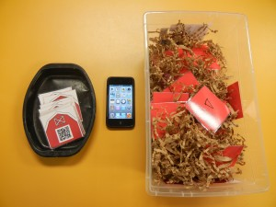
The cards that were hidden were the ones that looked like this:
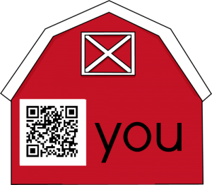
Then, each child also had their own individual deck of cards that looked like this:
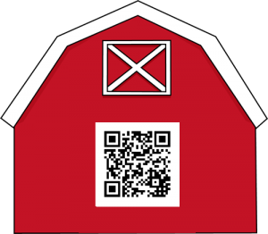
Their task was to scan the card that had *just* the QR code. It would say something like, “Find the word you.” The child would then look through their tub and try to find that particular sight word. When they found the word that they thought might be “you,” they would take it, and scan that card to see what the word really said.
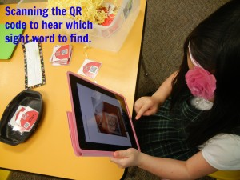
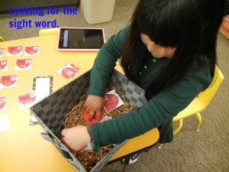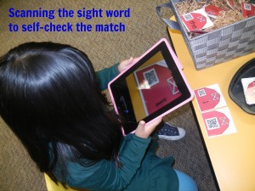
I was nervous when we put the kids to work on this activity. Like there always is with technology, there was a lot of room for things to go wrong. Fortunately, I think the activity turned out well! All of the technology worked smoothly, and the educational aspects worked well too. I watched proudly as my students were able to scan an item, listen to the audio file, make the match, scan the match to confirm it, and then navigate back to the scanner to start the process over again. That is A LOT of steps for preschoolers, and they handled it beautifully. They were even able to re-play the audio file if they forgot which word they were searching for. I know that this would have been too much for them if it were their first scanning activity, but since we’d done several QR code activities previously, they were very comfortable with scanning. They rocked the technology aspect of this activity, and of course, I do think this activity also helped them practice their sight words.
I learned a lot too. For example, I know I’m going to make the QR codes bigger next time. Some of them were tricky to scan because of their size. I also learned that my students only had a 15 minute attention span for this activity. It was a lot for them to handle and while they really had fun, after about fifteen minutes, they were done.
I had a lot of fun creating this activity. I’m hoping that I’ll be able to use all of my audio files that are linked to QR codes for some other fun sight word activities. I’ll post about those when I’ve got them made. In the mean time, you’re welcome to download this activity, with just a few caveats:
*I recommend using the same scanner that we have installed on our ipods and ipads at school. When I tried to scan the code with my android phone, not only did I have to click “play” on the audio file, I also had to click to access the link. (WAY too many steps for my preschoolers!) The process was seamless with this QR code reader and our apple products.
*I’ve learned that audio files are particular and don’t always work the way you want them to, particularly when switching between mac and pc, so there could be some glitches.
*Printing in color or on white paper seems to work best. When I printed on red paper the words didn’t show up.
Click the image to download your own set of QR Codes for Sight Words. If you decide to use or tweak this activity, I’d love to hear about how it goes for you.
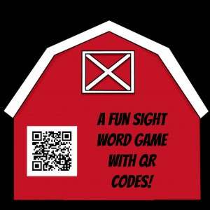

CHILDREN’S LITERATURE
Identifying themes in Sacramental Celebrations: Using Literature that supports students engaged in sacramental preparation and celebration.
Book & Author | Age Group | Concepts/Themes | Sacraments
All the places to Love by Patricia MacLachlan | Early Years | Welcoming  Belonging  Ritual/Tradition | Baptism  Confirmation
Pocket Dogs by Margaret Wild | Early Years | Belonging/community  Concern  Home | Baptism
Nighty Night by Margaret Wild | Early Years | Identity  Belonging  Ritual | Baptism  Confirmation
Max by Bob Graham | Early Years | Identity/Vocation  Affirmed/Conviction | Confirmation
Let’s Eat by Ana Samorano | Early Years to Middle Primary | Belonging/acceptance  Sharing a family meal  Ritual/celebration | Baptism  Eucharist.
Guess How Much I Love you by Sam McBratney | Early Years | Belonging  Affirmation | Baptism
Mutt Dog by Stephen Michael King | Early Years | Belonging  Community | Baptism
The Busy Spider by  Eric Carle | Early Years | Belonging  Community | Eucharist
The Rainbow Fish,  by Marcus Pfister | Early years | Belonging  Community | Eucharist
Seven More Sleeps by Margaret Wild & Donna Rawlins | Early Years | Ritual/ Celebrations  Community | Baptism  Eucharist
John Brown Rose and the Midnight Cat  By Jenny Wagner | Early Years | Friendship/belonging  Trust/integrity  Forgiveness/Acceptance | Reconciliation
Miss Lily’s Fabulous Pink Feather Boa by Margaret Wild | Early years | Friendship/belonging  Trust/integrity  Forgiveness/Acceptance | Reconciliation
Ping Won’t Share by Lynne Giggs & Melanie Mitchell | Early Years | Friendship  Trust  Honesty  Forgiveness | Reconciliation
Remember Me by Margaret Wild & Dee Huxley | Lower Primary | Memory  Empathy/ Support  Sensitivity | Anointing of the Sick
It Must Have Hurt A Lot by Doris Sanford | Early Years | Grief  Loss  Sensitivity  Growth/Changes | Anointing of the Sick
Mr Nick’s Knitting by Margaret Wild and Dee Huxley | Early Years | Support/Empathy  Friendships  Identity  Friendship | Confirmation  Anointing of the Sick

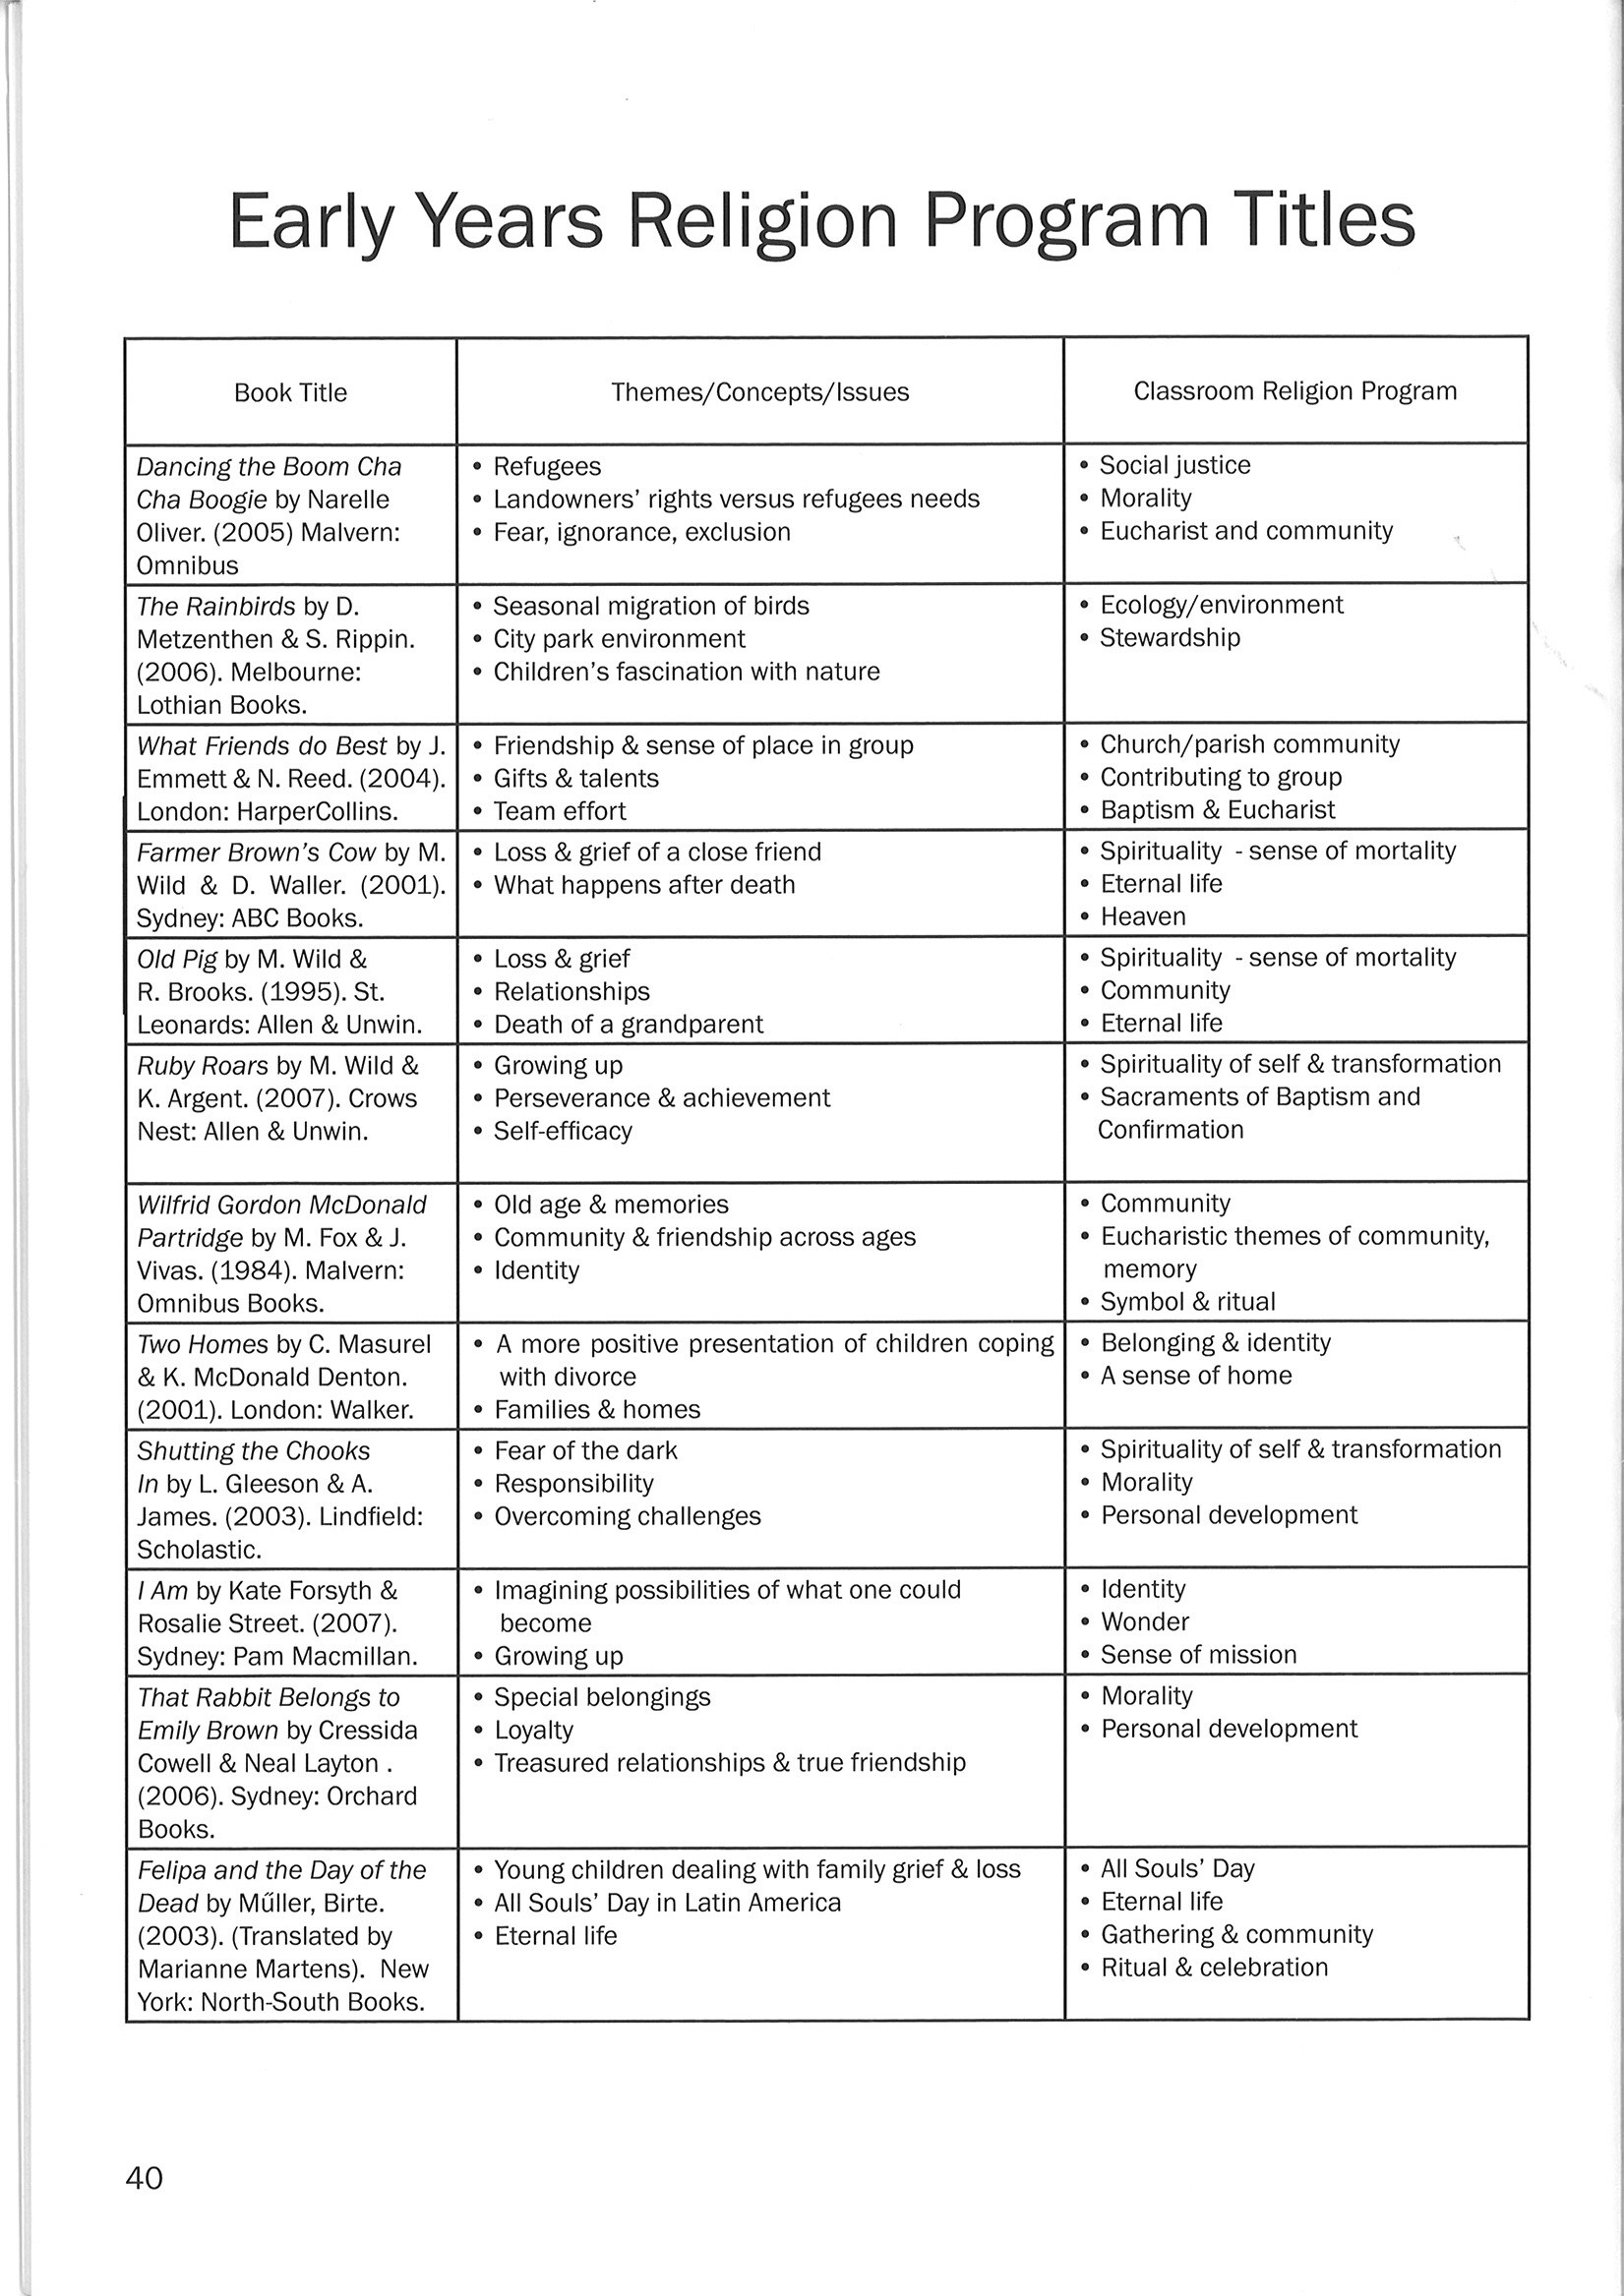

Learning Links to Story in Religious Education: Teacher Resources for the Religion classroom. By Maurice Ryan and Jan Grajczonek

RESOURCES

Twitter - @Joatceo
Pinterest – pinterest.com/ambuntiprincess or pinterest.com/djac123/bible-jesus-his-birth/ for Nativity ideas.

