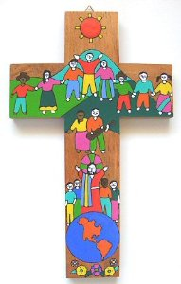**RELIGIOUS**

**EDUCATION**

**IN THE**

**EARLY YEARS**

Joanne Harris

Consultant

Religious Education and Faith Formation

Catholic Education Office

[harris.joanne@cathednet.wa.edu.au](mailto:harris.joanne@cathednet.wa.edu.au)

@JoatCEO

 /ambuntiprincess

www.reintheey.weebly.com

**~ KINDY**

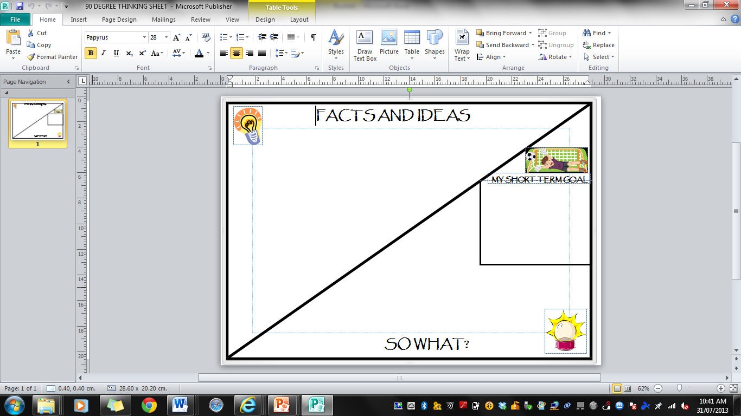

**YOU KNOW YOU’RE AN EARLY YEARS EDUCATOR WHEN…**

1. You sing the “clean-up song” when cleaning at home.

2. You chant "Ten Little Monkeys Jumping on the Bed" to yourself while walking down the street.

3. You hand the person in front of you at the shops a tissue when she sneezes.

4. You use the term "phonemic awareness" in your day-to-day conversations.

5. You explain to parents in the park how much their kids are [learning](http://www.naeyc.org/blogs/sfriedmannaeycorg/2014/01/you-know-you-teach-preschoolers-when) when they dig in the dirt.

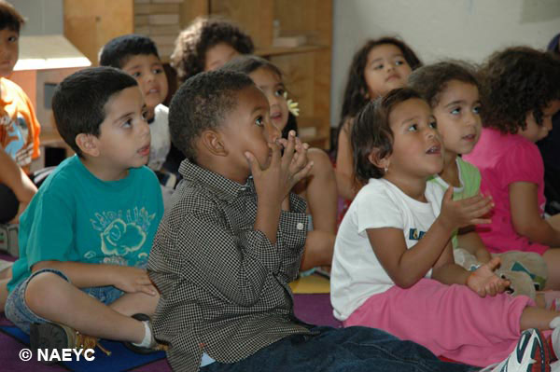6. You tell a dad in the grocery store, who waits patiently as his son counts all the apples, how he's supporting his son's learning.

7. You are used to the fact that the children think the classroom is where you live.

8. You can find 20 ways to use empty [yoghurt](http://www.naeyc.org/blogs/sfriedmannaeycorg/2014/01/you-know-you-teach-preschoolers-when) containers as learning materials.

9. You can count a group of toddlers in 5 seconds.

10. You wash your hands at least 30 times a day

11. You know that a child who drew two random lines has a whole story to tell when you ask, "Tell me about your drawing." And you write it down.

12. You print more pictures of the young children in your class than your own family.

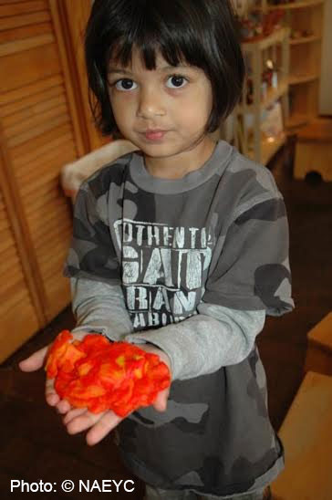

13. You’ve actually eaten what you’ve baked as a class, no matter the preparation, ingredients, or outcome.

14.  You know that when children draw, paint, make art - it's about the process and not the product.

15 You deserve a Nobel Peace [Prize](http://www.naeyc.org/blogs/sfriedmannaeycorg/2014/01/you-know-you-teach-preschoolers-when) for the arguments you’ve mediated and tantrums you’ve redirected.

16.. You can turn a simple nature walk or trip to the grocery store into an action-packed learning adventure…..and connect it to EYLF outcomes.

My own... ____________________________________________________

Someone I’ve met…_____________________________________________

Someone else I’ve met…__________________________________________

Someone else I’ve met…__________________________________________

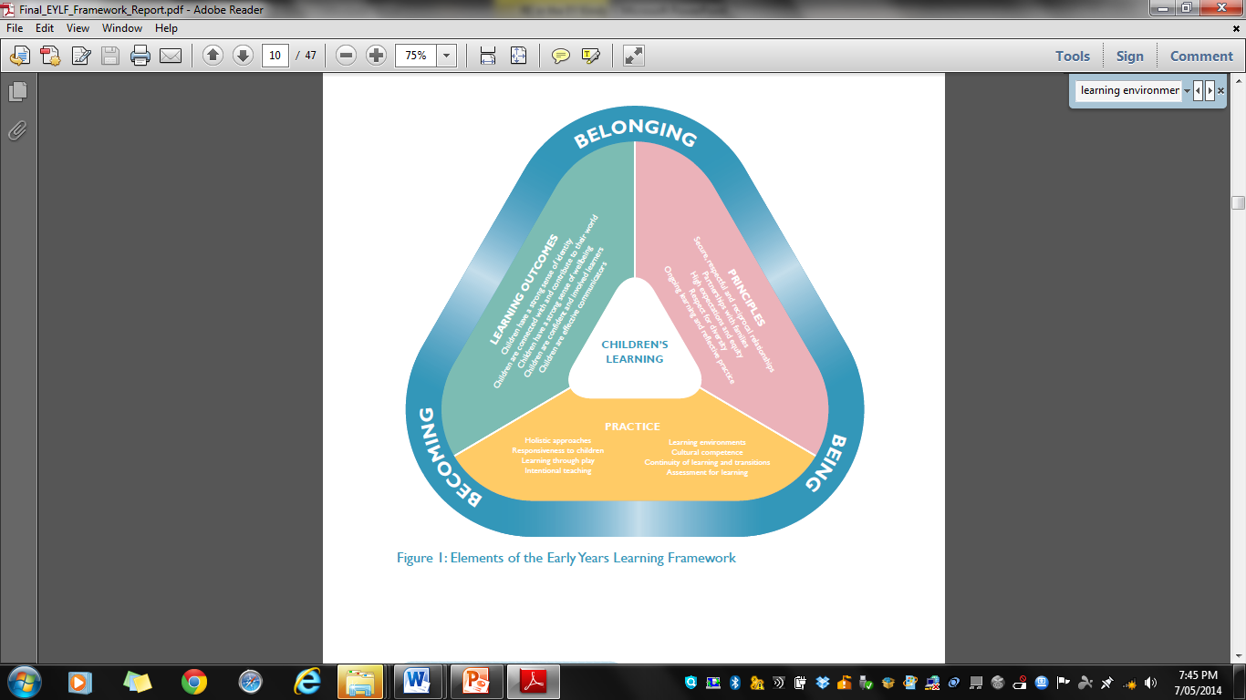**THE LEARNING ENVIRONMENT**

**~p. 15/16 EYLF**

Learning environments are welcoming spaces when they reflect and enrich the lives and identities of children and families participating in the setting and

respond to their interests and needs. Environments that support learning are vibrant and flexible spaces that are responsive to the interests and abilities

of each child. They cater for different learning capacities and learning styles and invite children and families to contribute ideas, interests and questions.

Outdoor learning spaces are a feature of Australian learning environments. They offer a vast array of possibilities not available indoors. Play spaces in natural environments include plants, trees, edible gardens, sand, rocks, mud, water and other elements from nature. These spaces invite open-ended interactions, spontaneity, risk-taking, exploration, discovery and connection with nature. They foster an appreciation of the natural environment, develop environmental awareness and provide a platform for ongoing environmental education.

Indoor and outdoor environments support all aspects of children’s learning and invite conversations between children, early childhood educators, families and the broader community. They promote opportunities for sustained shared thinking and collaborative learning.

Materials enhance learning when they reflect what is natural and familiar and also introduce novelty to provoke interest and more complex and increasingly abstract thinking. For example, digital technologies can enable children to access global connections and resources, and encourage new ways of thinking. Environments and resources can also highlight our responsibilities for a sustainable future and promote children’s understanding about their responsibility to care for the environment. They can foster hope, wonder and knowledge about the natural world.

Educators can encourage children and families to contribute ideas, interests and questions to the learning environment. They can support engagement by allowing time for meaningful interactions, by providing a range of opportunities for individual and shared experiences, and by finding opportunities for children to go into and contribute to their local community.

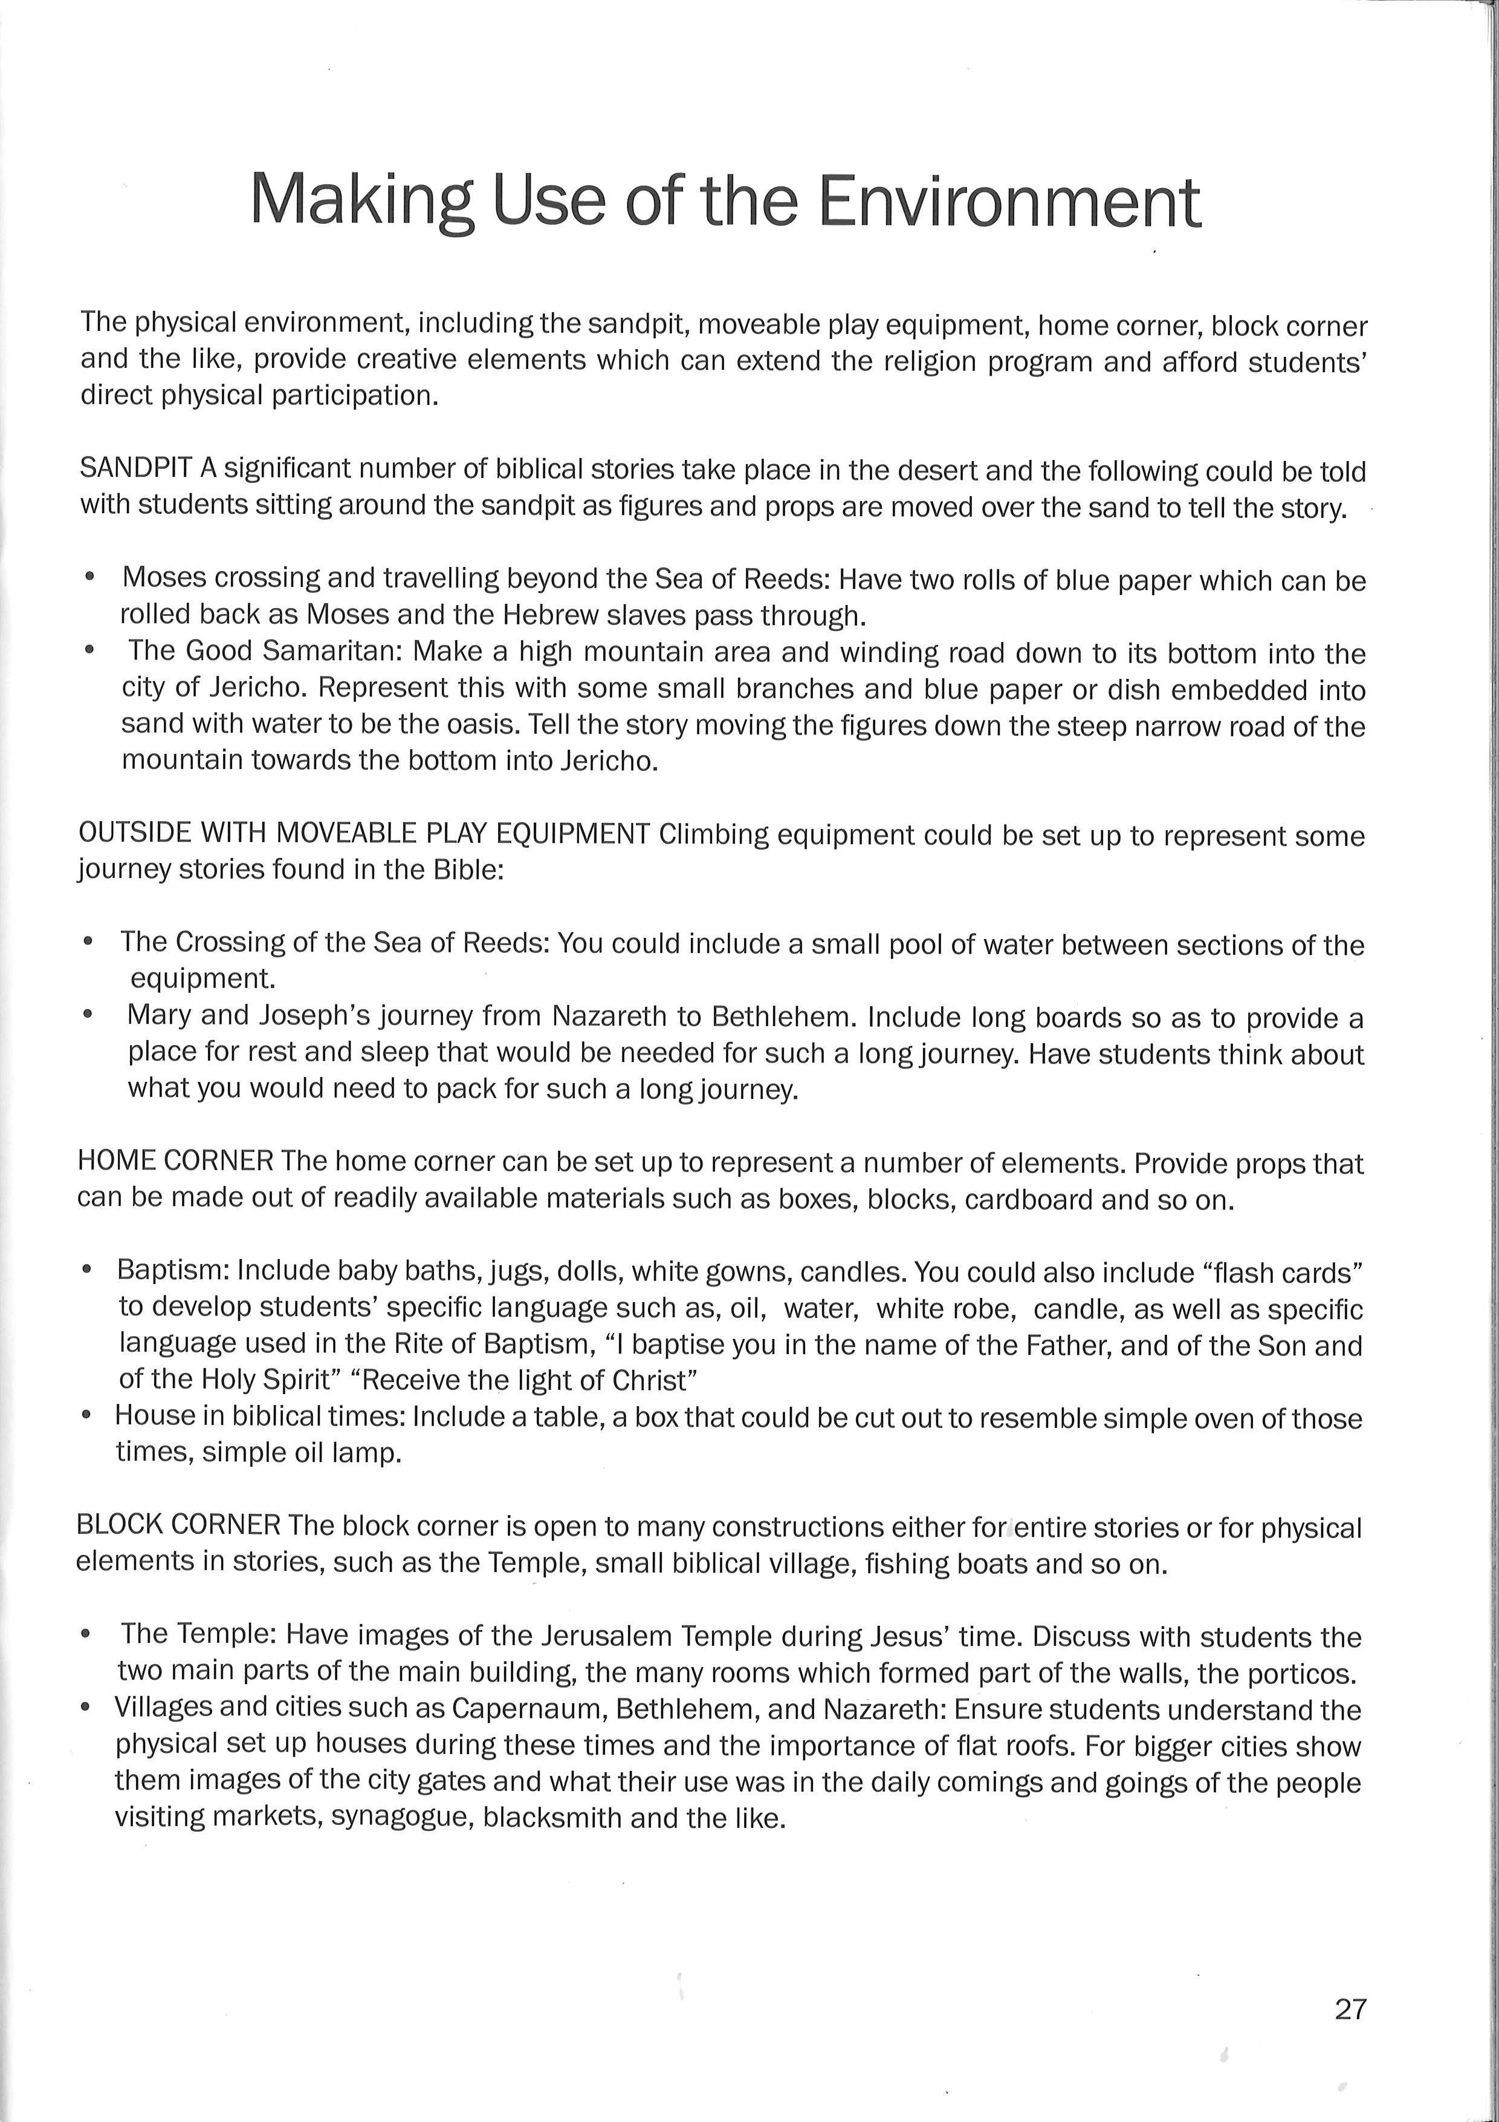

From “Learning Links to Religious Education in Early Childhood” by Maurice Ryan and Jan Grajczonek.

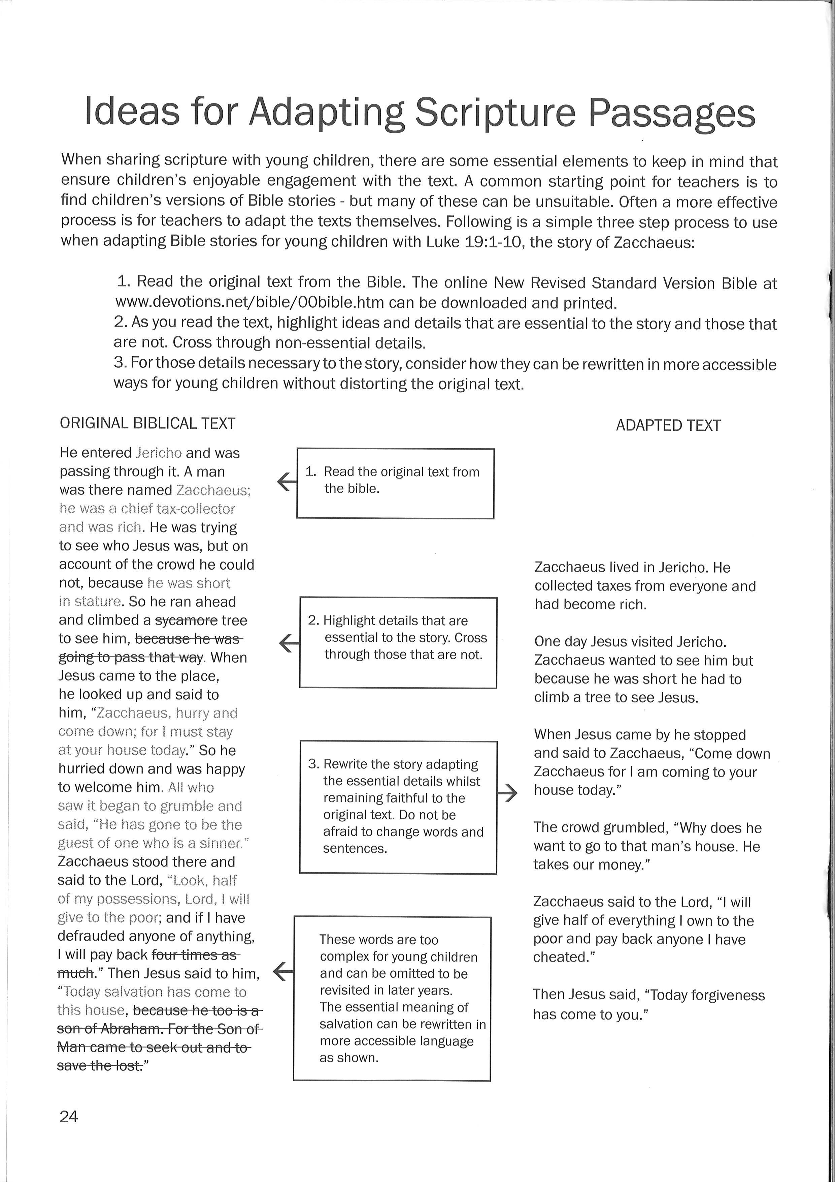

From “Learning Links to Religious Education in Early Childhood” by Maurice Ryan and Jan Grajczonek.

[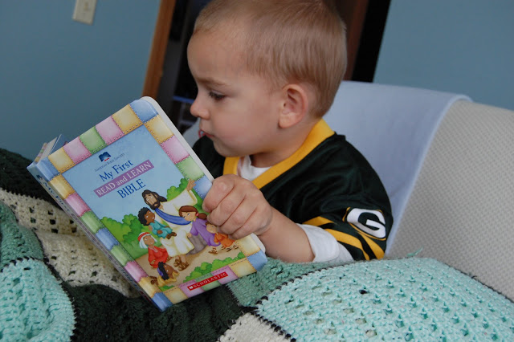](http://2.bp.blogspot.com/_QQXij2UzrgY/TKvqFeMV5iI/AAAAAAAABzk/6wZoYi5hK_s/s1600/DSC_0823.JPG)**Children’s Bible traveling bag**  
By Lisa Durant   
Catechist  
St. Michael Parish  
Cranford, New Jersey

I have done a traveling Bible with my many first grade classes. I found that most of the children did not have Bibles at home and knew very few stories and lessons from both the Old and New Testaments. They didn't know the stories of Jonah, Joseph, Moses, Lazarus, Zacchaeus, and even Jesus and his apostles.

I wanted the children to read scripture stories at home so their families could be involved and learn with them. I purchased a beautiful children's Bible with gold pages and very colorful illustrations. It was placed in a canvas bag with several pages of white drawing paper and an instruction sheet (addressed to parent and child).

Each week, the Bible went home for the week with a different child. The child could read as many stories as she/he wanted, from either testament. The children were encouraged to read with a parent to strengthen reading skills and have the parent involved in what they were learning in religious education. The child then had to pick his/her favorite story and draw a picture on one page. Some children picked one favorite story from the Old Testament and New Testament.

The following week after opening prayer, the child would come up to the front of class and tell us his/her favorite story, show us his/her picture and tell us what they learned from the story. I would put a sticker on the picture and hand it back to take home for display. Then the child would ceremoniously pass on the Bible to the next student to take home.

The children loved learning the favorite stories of their classmates and it prompted them to want to read stories that they were not familiar with when it was their turn. This also was a wonderful opportunity for the child and parents to read the Bible together and learn to love scripture.

**FEEDBACK FROM RELIGIOUS EDUCATION IN THE EARLY YEARS 2013**

**~3 AND 4 YEAR OLD KINDY**

**The goals of the day were:**

* to look at how the environment in a Kindy classroom can assist Religious Education learning
* to examine programming and assessment in the Kindy classroom
* to look at how to adapt scripture passages for use with Kindy students
* to give teachers time to network and share ideas.
* to explore the use of ICT in the teaching of RE in the Kindy.

Did you feel that the activities throughout the day met these outcomes? Please explain your answer.

What did you find particularly helpful in the sessions today?

What would you like to see covered in future Kindy RE in the Early Years PDs?

Thank you for your participation and feedback ☺