

Candle



Crucifix



Chalice



*Cross*



*Holy Water*



*Organ*

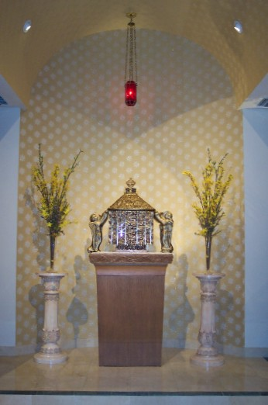

*Tabernacle*

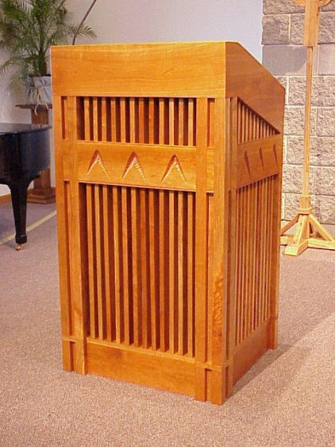

*Ambo*

*Stained Glass Windows*



Altar



Vestments



Pew