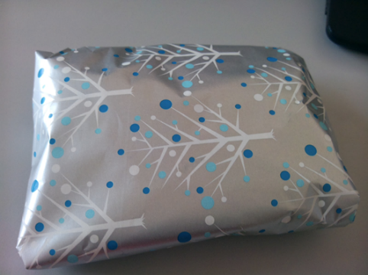
PASS THE PARCEL BIBLICAL STORY PLANNER

LAYER | PROP/ILLUSTRATION

