[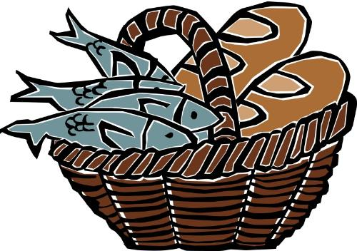](http://www.google.com.au/url?sa=i&rct=j&q=baskets%20loaves%20fishes&source=images&cd=&cad=rja&uact=8&ved=0CAcQjRw&url=http://teachingthem.com/2012/06/&ei=I1hEVaXsKcTTmAW6oYCQBA&psig=AFQjCNHBo2qgKtf20a1_HKumBcanyHy2ZA&ust=1430628746967749)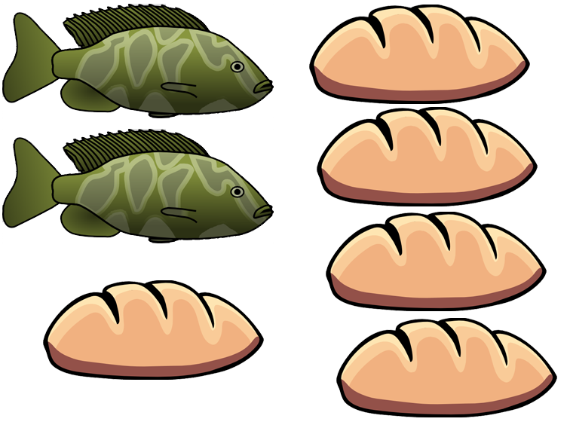

[](http://www.google.com.au/url?sa=i&rct=j&q=baskets%20loaves%20fishes&source=images&cd=&cad=rja&uact=8&ved=0CAcQjRw&url=http://teachingthem.com/2012/06/&ei=I1hEVaXsKcTTmAW6oYCQBA&psig=AFQjCNHBo2qgKtf20a1_HKumBcanyHy2ZA&ust=1430628746967749)

[](http://www.google.com.au/url?sa=i&rct=j&q=fishing+boat+jesus&source=images&cd=&cad=rja&uact=8&ved=0CAcQjRw&url=http://shepherdoftheridge.org/services/sermon-series-boat&ei=zFhEVZjQK4LXmgWIjoDAAw&psig=AFQjCNEgQLxwsKgmLgpy94IlA1Uf_XJ3aQ&ust=1430628924897589)



[](http://www.google.com.au/url?sa=i&rct=j&q=baskets%20loaves%20fishes&source=images&cd=&cad=rja&uact=8&ved=0CAcQjRw&url=http://teachingthem.com/2012/06/&ei=I1hEVaXsKcTTmAW6oYCQBA&psig=AFQjCNHBo2qgKtf20a1_HKumBcanyHy2ZA&ust=1430628746967749)

