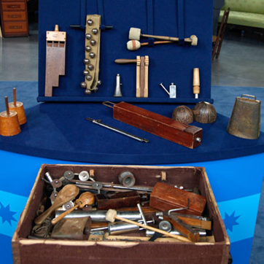
SOUND STORY PLANNER

STORY SCRIPT | PROPS

