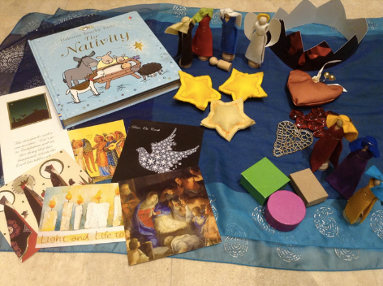
STORY BAG/APRON PLANNER
Purchase an inexpensive apron and decorate with fabric paint and add some extra pockets on to the front of the apron. Sing this little song before you start looking through the pockets.
1 little, 2 little, 3 little pockets, 4 little, 5 little , 6 little pockets, 7 little, 8 little, no more pockets ... In my story time apron.
Put items from a scripture story into the pockets to use to tell the story. For example: The Good Shepherd – Picture of shepherd, small play sheep, small wooden toy fence pieces. The Nativity (Luke’s version) – shepherds, angels, sheep, straw, donkey, star. The Nativity (Matthew’s version) – wise men, star, camel, three gifts, Mary, Joseph, baby Jesus. Jesus blesses the children – pictures of young children, Jesus, Jesus‟ disciples.

Felt apron: Attach felt onto the apron front and use your felt board story pieces on the apron front to re-tell the story. Keep your necessary pieces for the story in your apron pockets.
STORY SCRIPT | INSTRUCTIONS | PROPS
STORY SCRIPT | INSTRUCTIONS | PROPS

